1. **TRANSFORMATIONS**

**Problem Statement:**

Everything will revolve around the data in Analytics world. Proper data will help you to make useful predictions which improve your business. Sometimes the usage of original data as it is does not help to have accurate solutions. It is needed to convert the data from one form to another form to have better predictions. Explore on various techniques to transform the data for better model performance. you can go through this link:

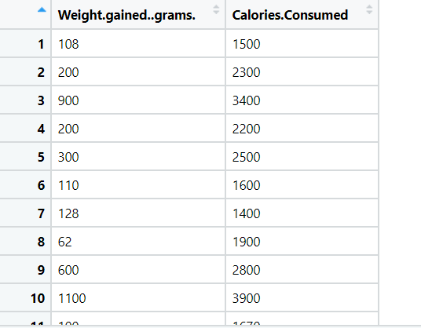

**Ans:-**

**Data types: -**

|  |  |  |  |
| --- | --- | --- | --- |
| **Name of features** | **Description** | **Type** | **Relevance** |
| Weight_gained_grams | Weight_gained_grams | Ratio | Relevant |
| Calories_Consumed | Calories_Consumed | Ratio | Relevant |